# In 2014, the Sri Lankan economy showed its resilience



**in the face of domestic as well as external headwinds**

## Highlights of the Economy

**Real sector and inflation**

* **Industry and Services sectors sustained the growth momentum in 2014**
* **Inflation remained at single digit levels for the 6th consecutive year**
* **GDP amounted to US$ 74.9 bn in 2014, compared to US$**

**67.2 bn in 2013**

* **GDP per capita increased to US$ 3,625 in 2014 from US$ 3,280 in 2013**

**External sector**

* **The current account deficit narrowed with iŶfloǁs froŵ trade iŶ serǀices aŶd ǁorkers’ remittances**
* **The balance of payments (BOP) and gross official reserves (GOR) strengthened**
* **Sri Lankan rupee, which remained broadly stable against the US dollar in the first nine months of the year, depreciated thereafter**

**Financial sector**

**Fiscal sector**

* The overall fiscal deficit as a percentage of GDP increased for the first time in the post conflict period
* The continued decline in revenue as a percentage of GDP led to an increase in the overall fiscal deficit to 6.0 per cent of GDP in 2014
* The capital of the banking sector was

maintained at a healthy level

* Total assets and asset quality of the banking sector improved

**Monetary Policy and Monetary sector**

* Low inflation enabled CBSL to ease monetary policy further
* Monetary expansion was in line with expectations during

the year

* Private sector credit growth was impacted by the decline in gold backed advances, but recovered
* Most market interest rates declined to historically low rates
* The performance of superannuation funds, insurance companies, primary dealers in government securities, and unit trusts also improved during the year

**4**

# Real GDP grew by 7.4% in 2014, in comparison to the

**growth of 7.2% in 2013**

### Continued domestic economic activity sustained the growth momentum, amidst

**adverse developments in the global economy.**

**Annual GDP Growth**

**Quarterly Real GDP Growth**

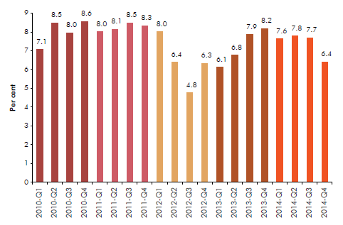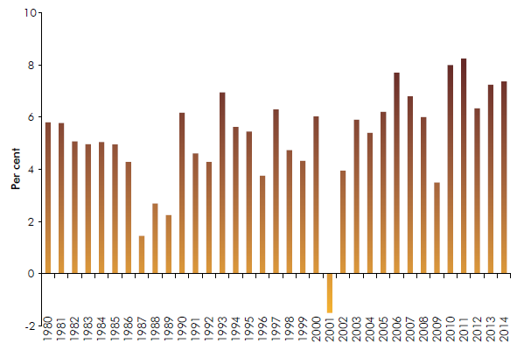

* **Economic growth was driven by domestic consumption expenditure.**
* **The growth in private consumption expenditure was supported by lower domestic interest rates and higher disposable incomes.**
* **Investments, particularly on construction, also gave an impetus to the economic expansion during the year.**
* **Higher contribution from the growth in imports relative to exports, however, resulted in a deterioration of net external demand. 5**

**Sectoral Growth Performance - 2014**

**Services (GDP share 57.6%): 6.5%**

**Sectoral Growth Rates**

* + **Wholesale and Retail Trade: 8%**
  + **Transport and Communication Services: 7.3%**

|  |  |  |  |
| --- | --- | --- | --- |
| **Sector** | **2012** | **2013**  **(a)** | **2014**  **(b)** |
| **Services** | **4.6** | **6.4** | **6.5** |
| **Industry** | **10.3** | **9.9** | **11.4** |
| **Agriculture** | **5.2** | **4.7** | **0.3** |
| **GDP** | **6.3** | **7.2** | **7.4** |

* + **Hotels and Restaurants: 11.5%**
  + **Banking, Insurance and Real estate: 6.6%**

**Industry (GDP share 32.3%): 11.4%**

* **Construction: 20.2%**
* **Manufacturing: 8.0%**

**Agriculture (GDP share 10.1%): 0.3%**

• **Paddy: 16.7%**

• **Tea: 1.2%**

* + **Rubber: 32.3%**
  + **Coconut: 7.9%**
  + **Other food crops: 7.0%**

1. **Revised**
2. **Provisional**



**6**